Sistemas Operacionais – Tarefa de casa

1. Get-Date

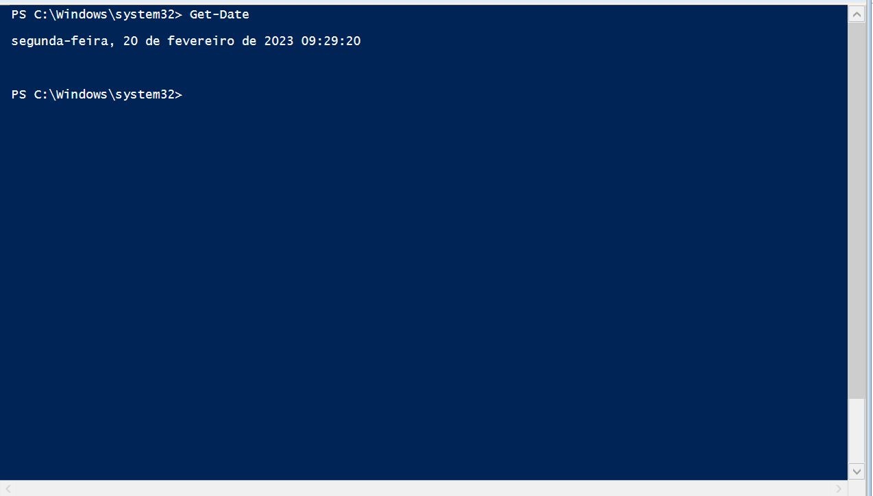

1. Get-Date –Date “01/08/2021”

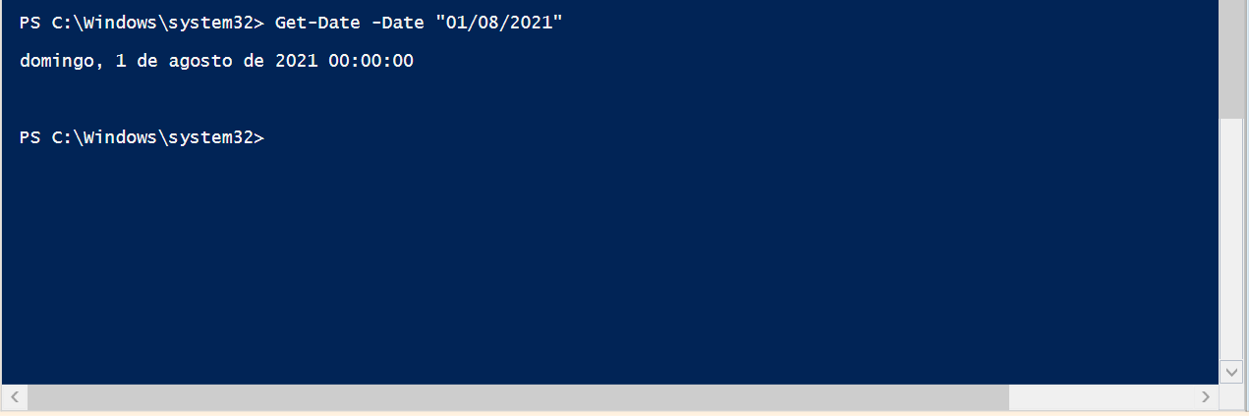

1. Get-Date –DisplayHint Date

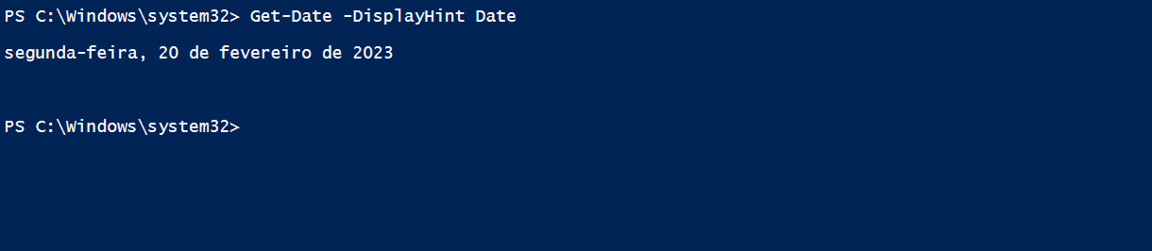

1. Get-Date –DisplayHint DateTime

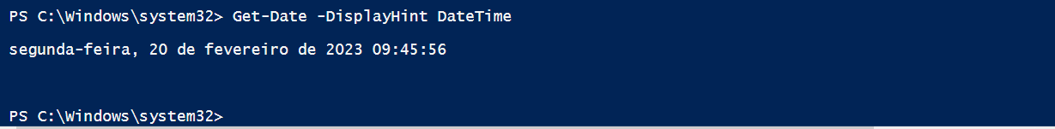

1. Get-Date –DisplayHint Time

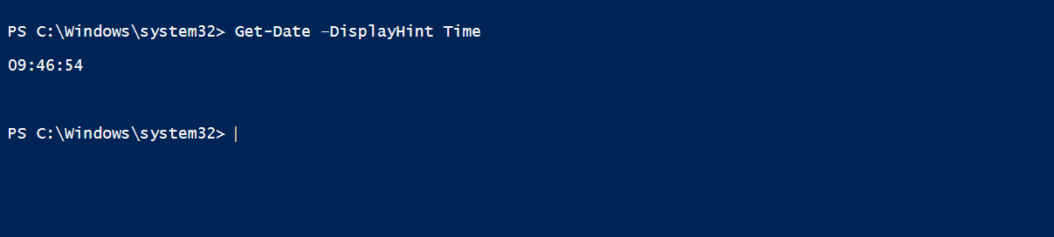

1. Get-Date –Year 1990

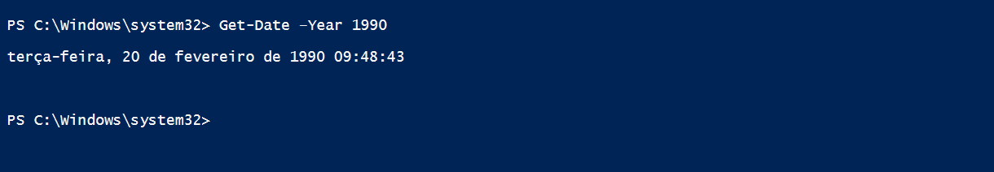

1. Get-Date –Year 2004 –Month 04 –Day 28

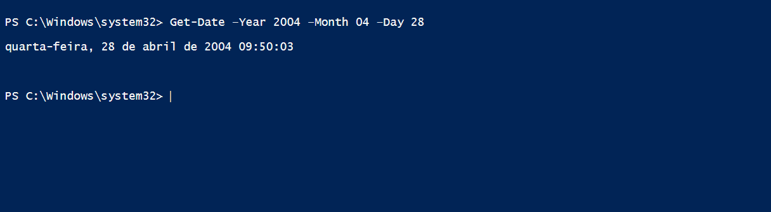

1. $DST.IsDaylightSavingTime()



1. Get-Command –Verb Get

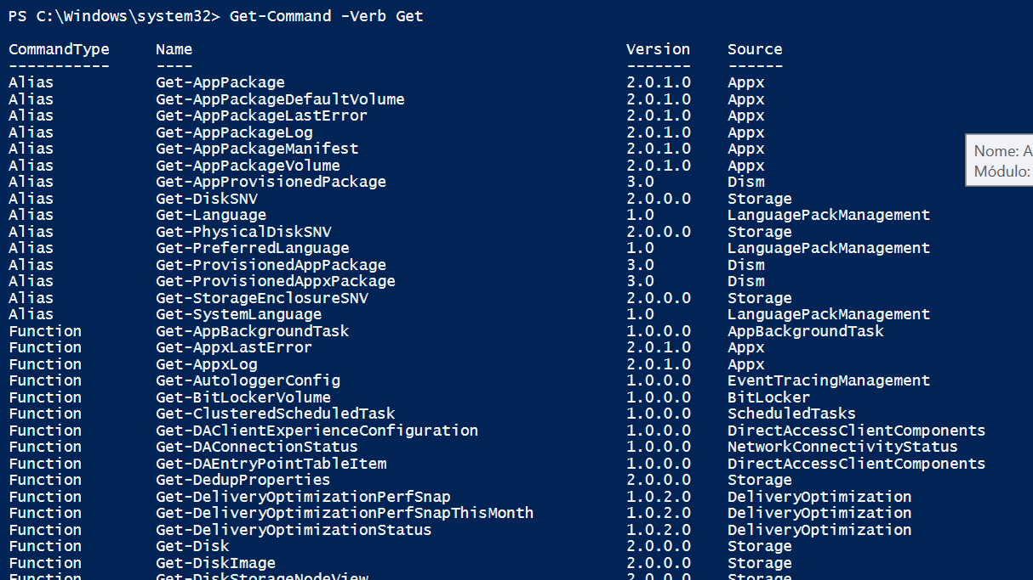

1. Cls, cd.., dir

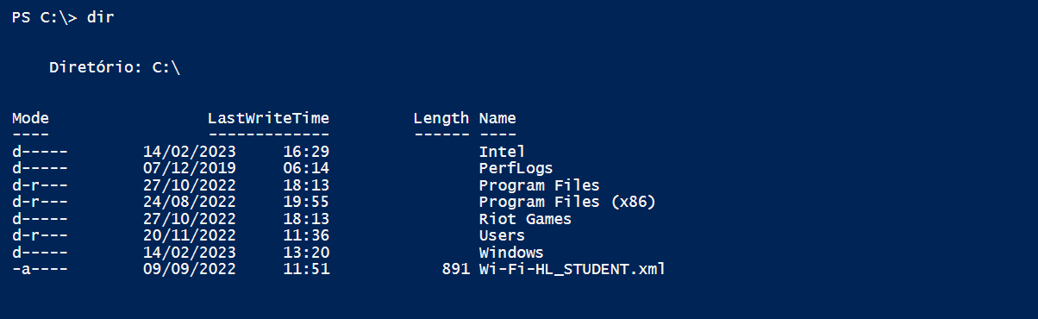

1. Cd Users

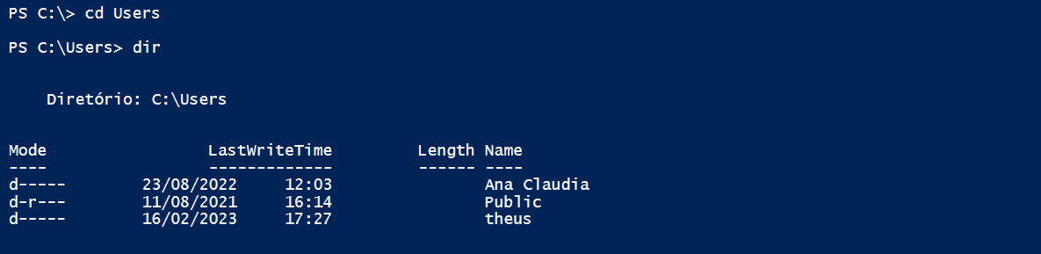

1. cd Public

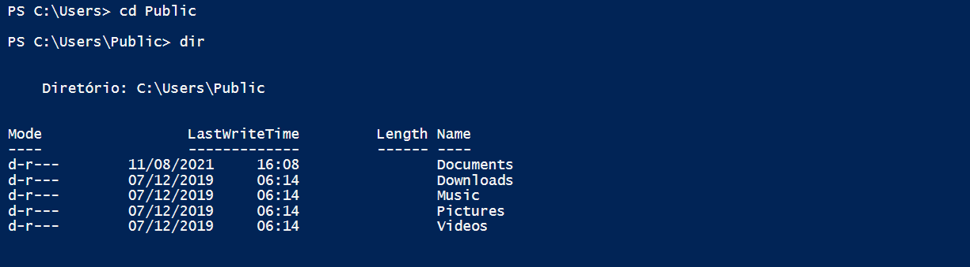

1. cd Documents, New-Item

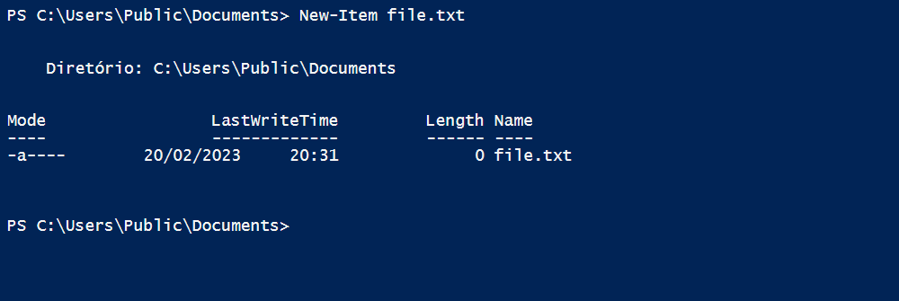

1. Adicionando informações no arquivo

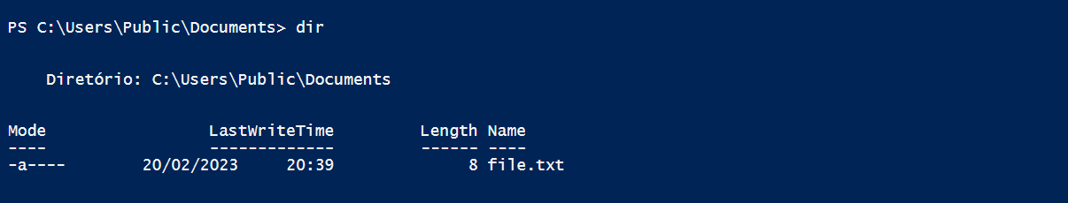

1. Concatenando os arquivos

